IoT Emerging Technology Assignment

*By Mei Chiao Lin, Oct 31st 2019*

First, for the Bluetooth Scan project, setup the Bluetooth scan application and test its functions of how it performs scanning and collects information. When ready, conduct the scanning and record the measured RSSIs, device names, farthest estimated distance, Bluetooth packet types, PHY channel used while advertising, and check if the message was connectable.

Second, for the Wi-Fi Network Analyzer experiments, setup the network analyzer app and test its functions. Then conduct the measurements and record the device’s internal and external IP addresses and gateway’s IP address, link data rate that the AP provides, PHY channel and bandwidth you are using, number of detectable Wi-Fi channel signals and the strongest and weakest signal strength detected. In addition, conduct a Ping to the gateway and record the results.

Third, for the Amazon EC2 project, after setting up your AWS cloud, attempt two EC2 cloud services and see what you can do with them. In your report, explain the two EC2 cloud services you used and the results you obtained.

**Project 1: BlueTooth Scan Project-**  
Tools/Apps used- BLE Scanner and BlueScan application which are used to scan bluetooth advertising messages.  
  
**1.BLE-SCANNER**: I scanned the nearby bluetooth devices which are advertising BLE messages and found these observations:

* ***Observations and Output:***

1. **Measured RSSI (Received signal strength indicator)**: -76dBm and -96dBm
2. **Device names**:n/a
3. **MAC address**: 44:98:7A:10:B8:80
4. **Bonded Connection**: NOT Bonded

After initiating connect mode to the device,  
Status Connected and Observed all these parameters:

* Device information
* Generic access
* Generic attribute
* Custom service
* Battery service
* Current time service.

**Device name**: UUID  00002A00-0000-8000-00805F9B34FB  
RAW DATA: 0x02011A0AFF4C0010050118C1D563  
  
**Farthest estimated distance**:Near Region 40-60m approx  
  
**2.BLUE SCAN app**: Scanned and tested Bluetooth packet types in two modes:   
 **Classic scan Time**:21:42  
Type:classic power  -92  
vendor:vendor not found   
Desc:OnePlus 6T  
  
**Low Energy Scan Mode**:21:43  
Type:scan power  -67  
vendor:vendor not found  
Desc:Empty LE Name field  
  
the messages were connectable.  
  
**Project 2: Wi-fi analysis project**Tools/Apps Used: Net Analyzer

* ***Observations and Output:***

Device internal address: 192.168.1.2  
Device external IP addresses: 182.68.19.1  
Gateway's IP address: 192.168.1.1  
Link data rate that the AP provides: 72Mbps  
Physical channel: 1  
Bandwidth: 2.4GHz  
Number of detectable wifi signals: 12  
Strongest and Weekest signal strength detected: -50dBm and -92dBm  
  
Ping to the gateway 192.168.1.1-  
  
192.168.1.1 209.4ms  
192.168.1.1 368.4ms  
192.168.1.1 281.6ms  
192.168.1.1 1865.1ms  
192.168.1.1 863.2ms  
192.168.1.1 136.6ms  
.....  
....  
  
**Project 3: AWS EC2 Project:**This is the best project in the course, i have tried upon windows,ubuntu and linux- three different OS.  
Some of them worked upon which iam sharing the records or observations. 

* ***Observations and Output:***

1.AMI-Microsoft **Windows Server 2012 Base-64 bit**(operating system, application server, and applications) using this i have created instances,storage,and completed the virtual computer creation till the end.  
  
Created virtual computer that gave the reading:

* Host Name: WIN-G5E085IHUP1
* Instance ID: i-09bee9f729e4fa66f
* Public IP address: 13.233.198.209
* Private IP adress: 172.31.27.133
* Availability zone: ap-south-1a
* Instance size: t2.micro
* Architecture : AMD64

2.**Microsoft Windows Server 2019 Base-64bit**(operating system, application server, and applications) using this i have created instances,storage,and completed the virtual computer creation till the end.  
  
EC2 feedback  
EC2 microsoft windows guide  
Recycle Virtualised comupte system was created finally.  
  
**Conclusion: Best Experience with wide credibility.**

5 devices were found within my reach. Scanned with an iPhone 7.

* The first device has a RSSI of -76dBm. It does not have a name nor does it have RAW DATA. It is not connectable and does not show the channel.
* The second device has a RSSI of -44 dBm. It does not have a name nor does it have RAW DATA. It is connectable but does not show the channel.
* The third device has a RSSI of -66 dBm. It has no name but it does have RAW DATA. It produces RAW DATA and is on channel 38. It is also connectable.
* The fourth device has a RSSI of -88 dBm. It has a name: 'Home'. It is my chromecast. It produces RAW DATA and is on channel 37. It is also connectable.
* The fifth device has a RSSI of -79 dBm. It has a name: 'iPad of Jan', but does not produce RAW DATA. It is connectable but does not show the channel.

**Wi-Fi Network Analyzer**

* Internal and external IP addresses: 213.127.18.xxx
* Gateway’s IP address: 192.168.178.1
* Link data rate that the AP provides: 150 Mbps
* PHY channel: 152
* Number of detectable Wi-Fi channel signals: 8
* Strongest and weakest signal strength detected: Best signal was at -34 dBm, the worst signal was at -91 dBm.
* Ping to the gateway: 33.0 ms, 22.5 ms, 21.1 ms, 21.8 ms, 23.6 ms

**Amazon EC2**  
The first service I used was EC2 and I installed an web server on it. I gave the EC2 instance an internet facing IP address so I could reach it via the internet. Next, I created a S3 bucket and linked the EC2 instance to the S3 bucket. In the S3 bucket I uploaded a picture. Via the direct internet link (IP Address + file name) I could reach the file and look at the picture online.

3 **AWS EC2 Project :**

AWS Service : EC2  
I have launched 2 EC2 Instance with below details in Default VPC Cloud.These EC2 severs can work as Web Servers. I have enable Port 22 & Port 80 in Security Group of EC2 instance for ssh & HTTP access of these Web Servers. Have also downloaded the key for remote access of these servers.  
  
Name:IoT Project Test 1 Istance ID:i-0598a0101fb89b9d  
Instance Type: t2.micro   
Availability Zone: us-east-1c   
Instance State: running    
Status Checks : 2/2 checks   
IPv4 Public IP : 54.175.172.122   
Private IPs : 172.31.94.1   
AMI ID: amzn2-ami-hvm-2.0.20190618-x86_64-gp2 (ami-0b898040803850657)   
VPC ID : vpc-95d3eeefd (Defaut VPC)  
Public DNS (IPv4) ec2-54-175-172-122.compute-1.amazonaws.com   
Security Group: sg-0037fb7525c653760   
Key pair name: ARVPP6978G  
  
Name:IoT Project Test 2Istance ID:i-080d0b3b8770df1d7  
Instance Type: t2.micro   
Availability Zone: us-east-1c  
InstanceState: running   
Status Checks : 2/2 checksIPv4   
Public IP :18.233.159.22   
Private IPs : 172.31.92.31  
AMI ID: amzn2-ami-hvm-2.0.20190618-x86_64-gp2 (ami-0b898040803850657)  
VPC ID : vpc-95d3eeefd (Defaut VPC)  
Public DNS (IPv4) ec2-18-233-159-22.compute-1.amazonaws.com   
Key pair name: ARVPP6978G  
  
AWS Service : S3  
I have created S3 Bucket with below details & uploaded one object in it.

Bucket Name : mickbucket2019  
Versioning : Ebabled  
Static Website Hosting : Disabled  
Object Created within S3 bucket  
  
Object Name : Test_data.txt  
Storage class : Standard   
Server-side encryption :None   
Size: 70.0 Byte  
Key : Test_data.txt

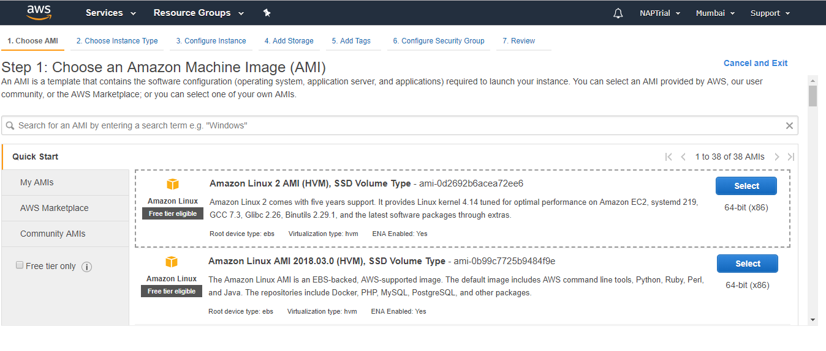

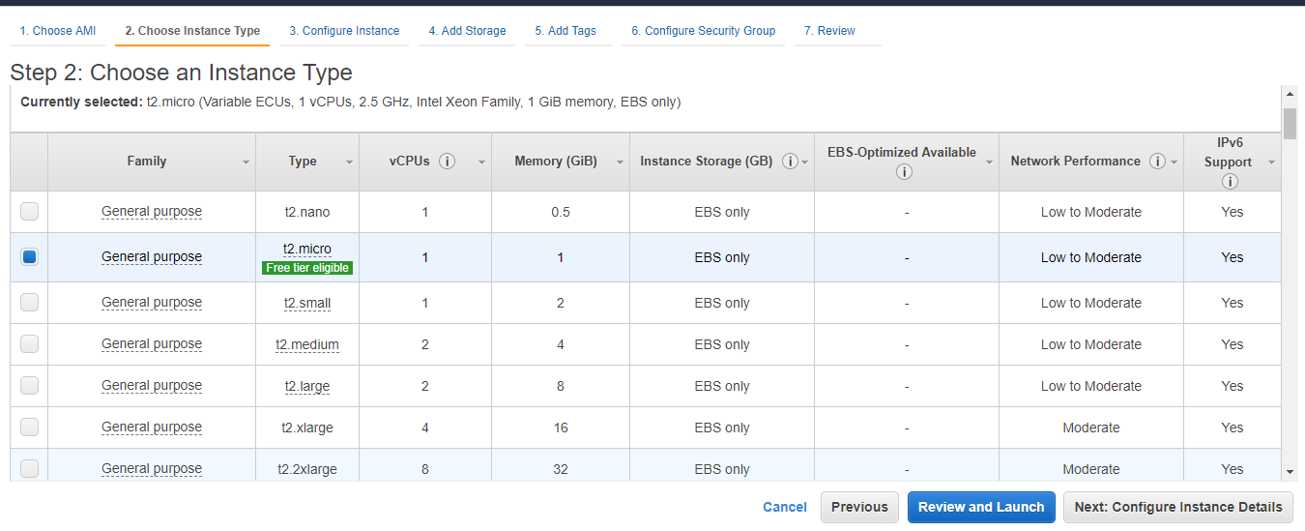

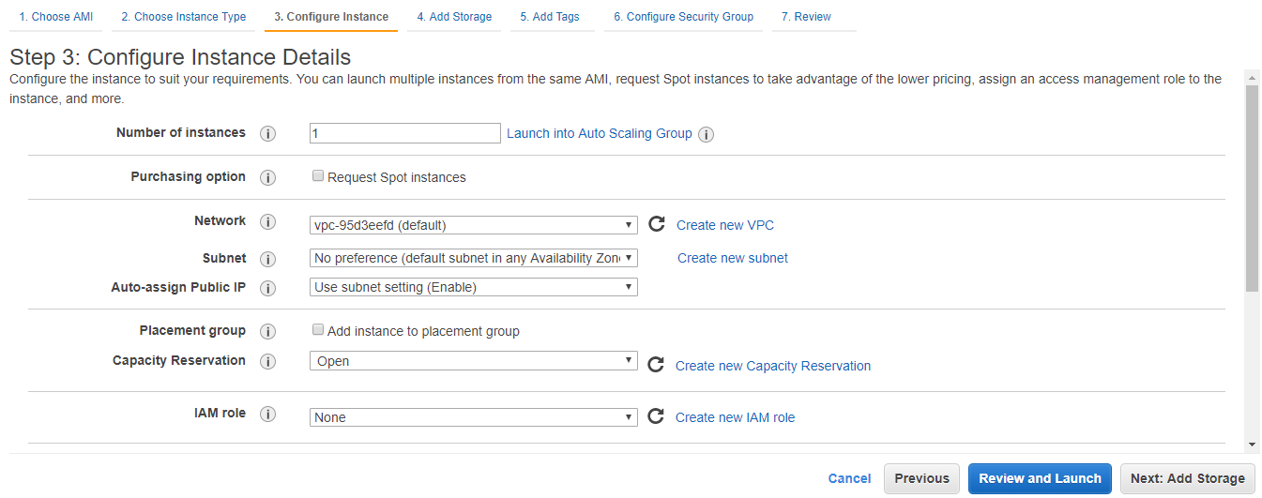

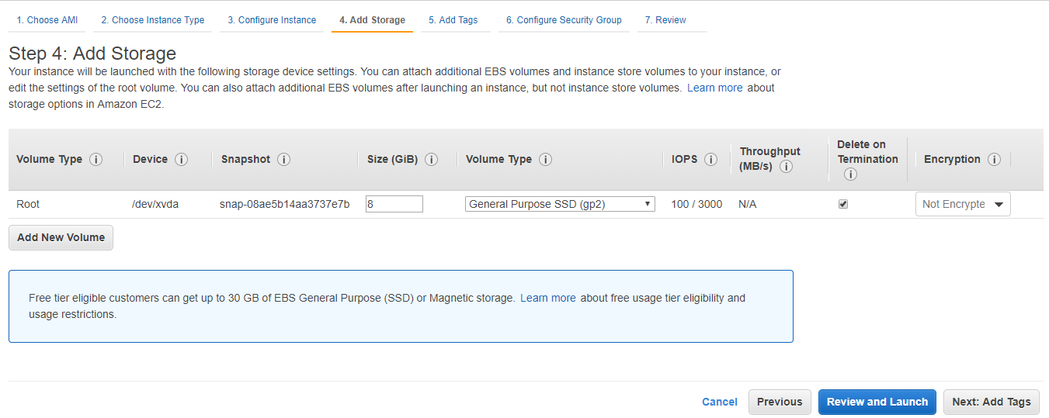

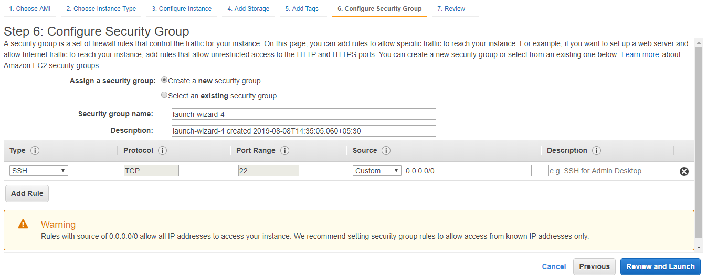

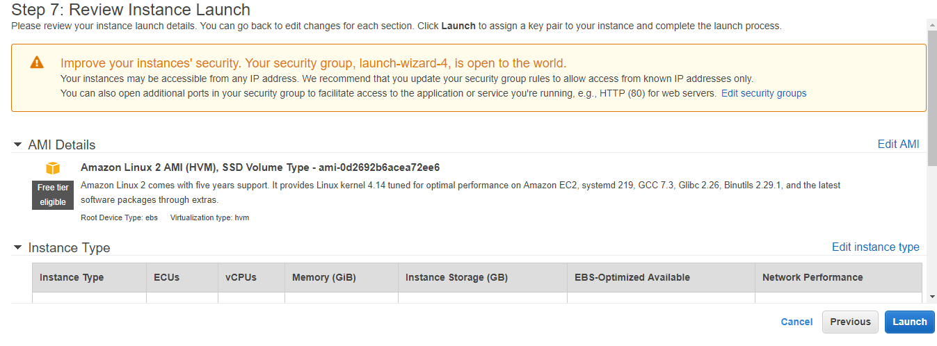

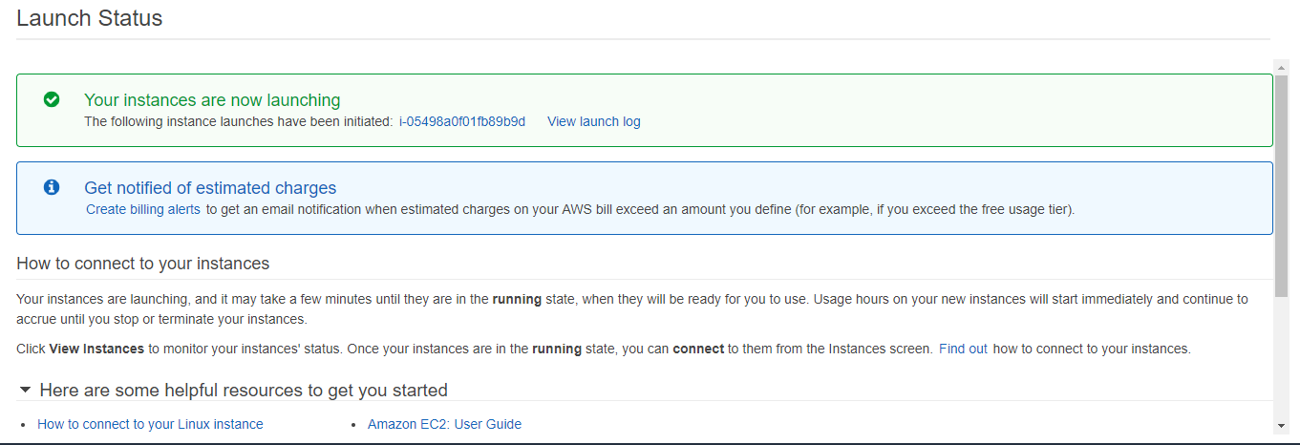

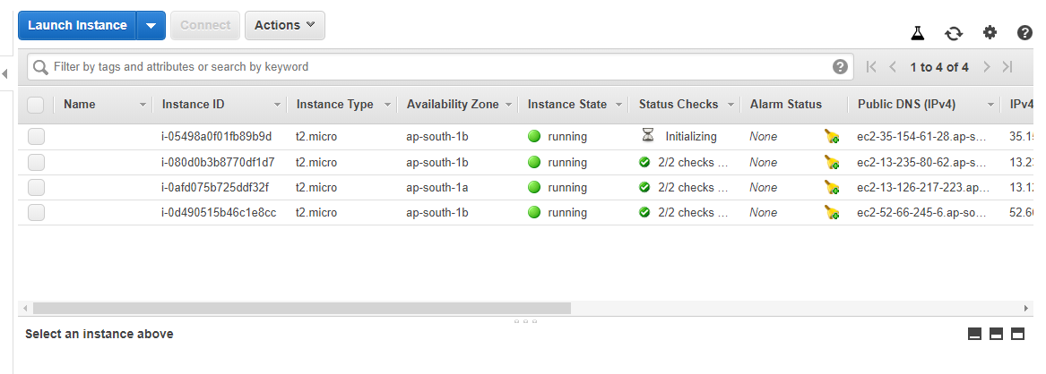

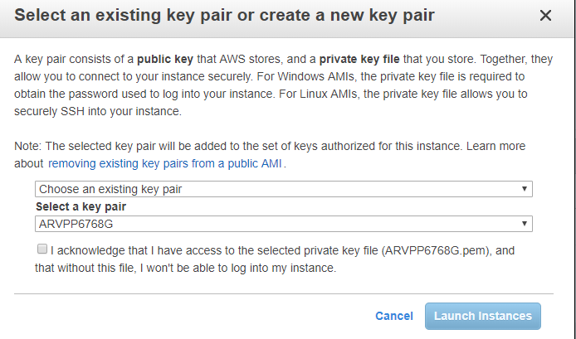

End Of Document-

**1 Bluetooth Scan Project -**

* 1. Bluetooth Scan 1 -

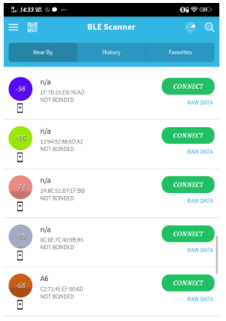https://docs.google.com/drawings/d/ssHjgFh0hOVS-Wx_fdoyEGQ/image?w=60&h=357&rev=1&ac=1&parent=15igLDZVD-47YtrTFdKH0T8NuYGk7Fg5YJ4FO0qMqf2M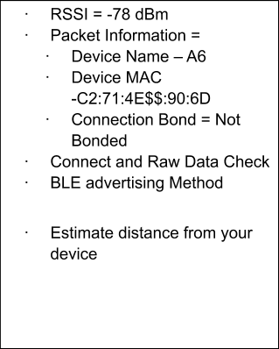

1.2 Bluetooth Scan 2 -

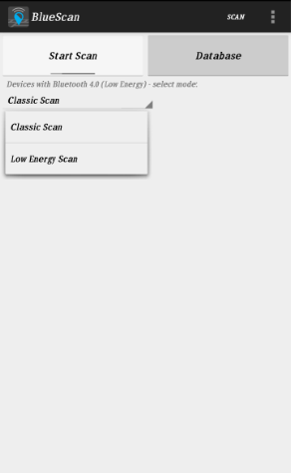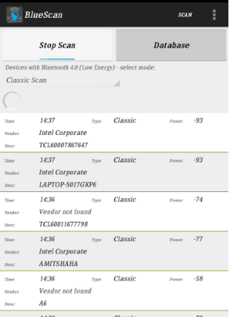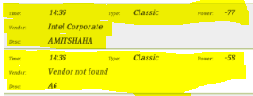

**2. Wi-Fi Analysis Project –**

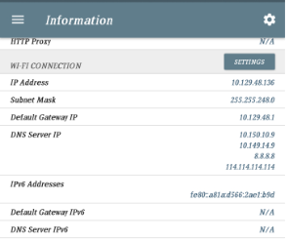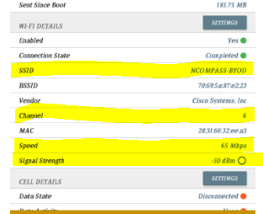

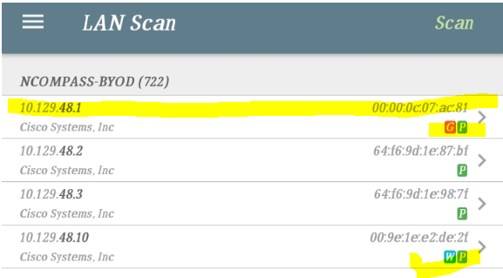

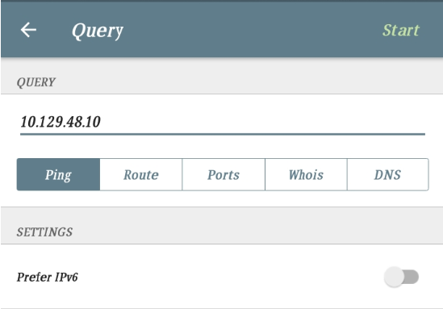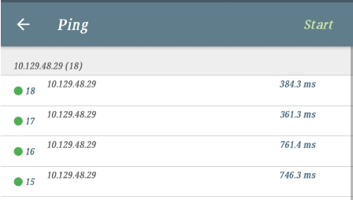

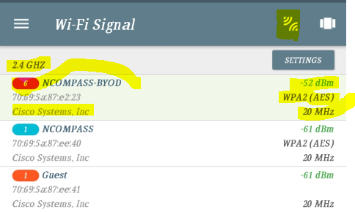

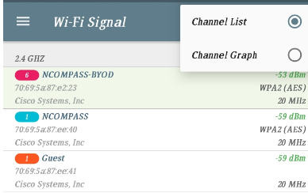

Channel Graph -

